Bug_id_01
Bug Description:
The search bar on the Follow Up page does not work. Entering any text does not filter or show relevant follow-up entries, making the search feature completely non-functional.
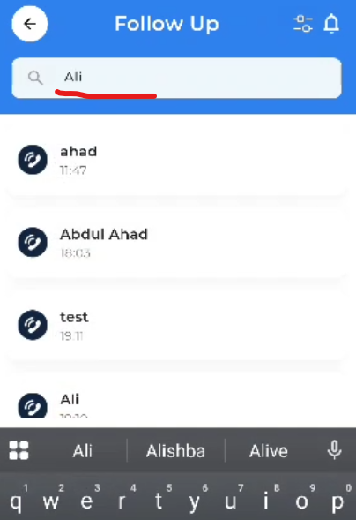

Bug_id_02
Bug Description:
On the Follow up page, the Industry dropdown menu in the filter only shows three options: IT, Finance, and Health. This is too limited and should include more industry options such as Education, Retail, Manufacturing, etc., to properly categorize leads.
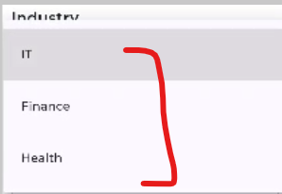

Bug_id_03
Bug Description:
On the Follow up page, the Business dropdown menu only contains generic placeholder options: Business A, Business B, Business C. There is no option for users to add or select their own business if it is not listed. This makes the filter unusable for real business selection.
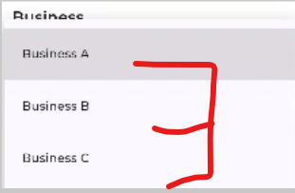
Bug_id_04
Bug Description:
On the Follow up page, the filter function does not work. Selecting any industry, business, lead status, or date range and clicking "Apply" does not filter the leads list. The filter has no effect on the displayed results.
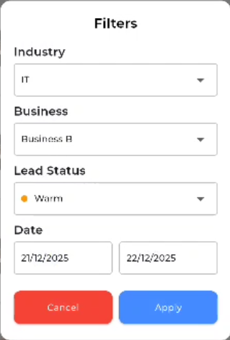
Bug_id_05
Bug Description:
On the Follow up page, the notification icon (bell/symbol) is non-functional. Tapping it does not open any notification panel, dropdown, or navigate to a notification screen.
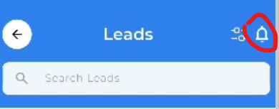

Bug_id_06
Bug Description:
The Lead Status filter only shows three options: Hot, Warm, Cold. It is missing the "Dead" status option, which is required for complete lead status filtering.
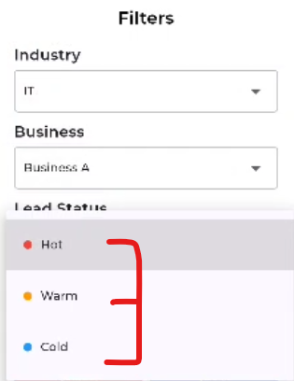

Bug_id_07
Bug Description:
The filter popup cannot be closed by tapping outside the popup area. The user must click the Cancel button to close it, which is not standard behavior and reduces usability.
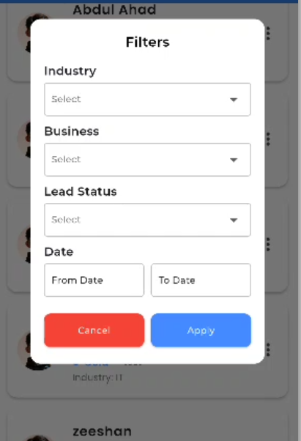

Bug_id_08
Bug Description:
Each lead entry on the Follow Up page should have a three-dot menu (•••) on the right side for options like Edit or Delete, but this menu is missing. This makes it impossible for users to edit or delete follow-up entries directly from the list.
